8.2 Data Flow Diagram DFD Level 2 - Assessment Process

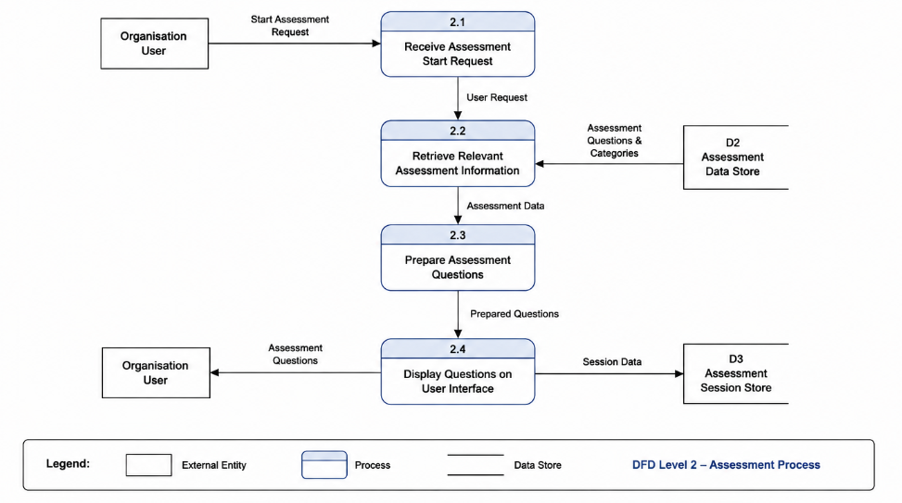
Figure X. DFD Level 2 – Conduct Assessment Process
This DFD Level 2 displays in detail how the Conduct Assessment process flow works. When the organizational user starts the assessment, the system receives the request, retrieves cybersecurity questions and categories from the Assessment Data Store (D2), prepares the assessment questions, and displays them to the user. The assessment session information is stored in the Assessment Session Store D3.

